**Health AI - Intelligent Healthcare Assistant Using IBM Granite**

**Team ID:** LTVIP2025TMID59956

* C Suchithra (Team Leader)
* D Vali
* Chinna Naganna Gavrivishnu Vardhan Raju
* Chapagalla Pavan Kumar

# Table of Contents

[Abstract 4](#_Toc201938942)

[Introduction 5](#_Toc201938943)

[Background of Health AI Project 5](#_Toc201938944)

[Importance of AI in Healthcare 5](#_Toc201938945)

[IBM Granite Model Capabilities 6](#_Toc201938946)

[Problem Statement 7](#_Toc201938947)

[Current Challenges in Healthcare Workflows 7](#_Toc201938948)

[Need for Automation and AI Assistance 7](#_Toc201938949)

[Objectives of the Internship 8](#_Toc201938950)

[Build a Chatbot for Patient Queries Using IBM Granite 8](#_Toc201938951)

[Summarize EHR Data Using NLP 8](#_Toc201938952)

[Implement a Symptom Checker 8](#_Toc201938953)

[Deploy the Assistant on IBM Cloud 8](#_Toc201938954)

[Scope of the Project 9](#_Toc201938955)

[Project Limitations and Focus Areas 9](#_Toc201938956)

[Expected Outcomes of Health AI 9](#_Toc201938957)

[Streamlit Framework Knowledge 10](#_Toc201938958)

[IBM Watson Machine Learning 10](#_Toc201938959)

[Python Programming Proficiency 10](#_Toc201938960)

[Data Visualization Libraries 10](#_Toc201938961)

[Version Control with Git 10](#_Toc201938962)

[Methodology / Implementation 11](#_Toc201938963)

[System Architecture Overview 11](#_Toc201938964)

[Chatbot Development Steps 11](#_Toc201938965)

[EHR Summarization Pipeline 11](#_Toc201938966)

[Symptom Checker Integration 11](#_Toc201938967)

[Deployment Process on IBM Cloud 11](#_Toc201938968)

[12](#_Toc201938969)

[Results and Observations 13](#_Toc201938970)

[Functional Demonstrations 13](#_Toc201938971)

[Performance and Accuracy 13](#_Toc201938972)

[Challenges Faced 14](#_Toc201938973)

[Technical Challenges 14](#_Toc201938974)

[Data Privacy Concerns 14](#_Toc201938975)

[Learning Outcomes 15](#_Toc201938976)

[Technical Skills Gained 15](#_Toc201938977)

[Domain Knowledge Gained 15](#_Toc201938978)

[Conclusion 16](#_Toc201938979)

[Future Scope 17](#_Toc201938980)

[Speech-to-Text Integration 17](#_Toc201938981)

[Multilingual Capabilities 17](#_Toc201938982)

[Real Hospital System Integration Securely 17](#_Toc201938983)

[References 18](#_Toc201938984)

# Abstract

# Health AI: Intelligent Healthcare Assistant Using IBM Granite" is a project focused on building an AI-powered assistant that answers patient queries, summarizes electronic health records (EHR), and performs symptom checks to support healthcare professionals. Using IBM Granite Foundation Models, it combines NLP and generative AI to deliver privacy-compliant, reliable healthcare information while reducing staff workload. The project includes chatbot development, EHR summarization, a symptom checker, and deployment on IBM Cloud, offering hands-on experience in healthcare AI, ethical AI integration, and real-world deployment.Introduction

## This project centers on leveraging advanced generative AI to enhance the efficiency and quality of healthcare services. In the face of rising patient volumes, healthcare providers often struggle with timely query resolution, effective summarization of electronic health records (EHR), and quick preliminary symptom assessments—all while upholding stringent privacy and data protection requirements.

## To address these issues, the project proposes the development of an AI-driven healthcare assistant powered by IBM Granite Foundation Models. This assistant will deliver accurate, context-sensitive responses to patient questions, create concise EHR summaries to support medical consultations, and conduct basic symptom checks to streamline patient triage processes.

## By automating routine tasks, the assistant aims to free up valuable time for healthcare professionals, ensuring compliance with healthcare data standards while improving workflow efficiency. With the integration of natural language processing and generative AI, this system will promote better patient engagement, reduce manual burdens on staff, and optimize healthcare operations.

## The project supports the broader mission of applying AI ethically and responsibly in the healthcare sector, making care delivery more accessible, efficient, and patient-focused. It also offers students meaningful exposure to real-world applications of AI, equipping them with valuable skills for the evolving landscape of healthcare technology.

## Background of Health AI Project

The Health AI project aims to build an intelligent healthcare assistant using IBM Granite Foundation Models to automate patient query handling, electronic health record (EHR) summarization, and symptom checking, improving healthcare service delivery.

## Importance of AI in Healthcare

AI technologies can help in reducing manual workloads, providing faster patient support, and ensuring accurate health data management, thereby improving efficiency and patient care in healthcare systems.

## IBM Granite Model Capabilities

IBM Granite Foundation Models offer advanced natural language processing and generative AI capabilities that can be used for healthcare-specific applications such as chatbot development, medical data summarization, and conversation-based symptom assessment.

# Problem Statement

## Current Challenges in Healthcare Workflows

Healthcare workflows often involve manual data entry, patient query management, and time-consuming record summarization, which can lead to delays and inefficiencies in patient care. Managing large volumes of patient data and responding promptly to queries requires significant effort from healthcare professionals, leading to increased workload and reduced focus on critical patient care.

## Need for Automation and AI Assistance

To address these challenges, there is a need for automation using AI-powered tools that can efficiently manage repetitive tasks, provide accurate information to patients, and assist healthcare professionals with summarizing medical data. AI assistance can enhance workflow efficiency, reduce manual errors, and enable healthcare providers to deliver timely and quality care while maintaining patient data privacy.

# Objectives of the Internship

## Build a Chatbot for Patient Queries Using IBM Granite

Develop an intelligent chatbot capable of answering patient questions related to symptoms, appointment bookings, and general health queries using the natural language processing and generative capabilities of IBM Granite Foundation Models.

## Summarize EHR Data Using NLP

Implement a module that uses NLP to automatically summarize patient electronic health records (EHR), providing concise and clear medical summaries to assist healthcare professionals in faster decision-making.

## Implement a Symptom Checker

Develop a symptom checker within the assistant to collect patient symptoms through conversation, compare them with healthcare datasets, and provide preliminary assessments while advising patients on potential next steps.

## Deploy the Assistant on IBM Cloud

Deploy the developed Health AI assistant on IBM Cloud, enabling accessibility, scalability, and testing in a cloud environment to ensure its availability for healthcare users and professionals

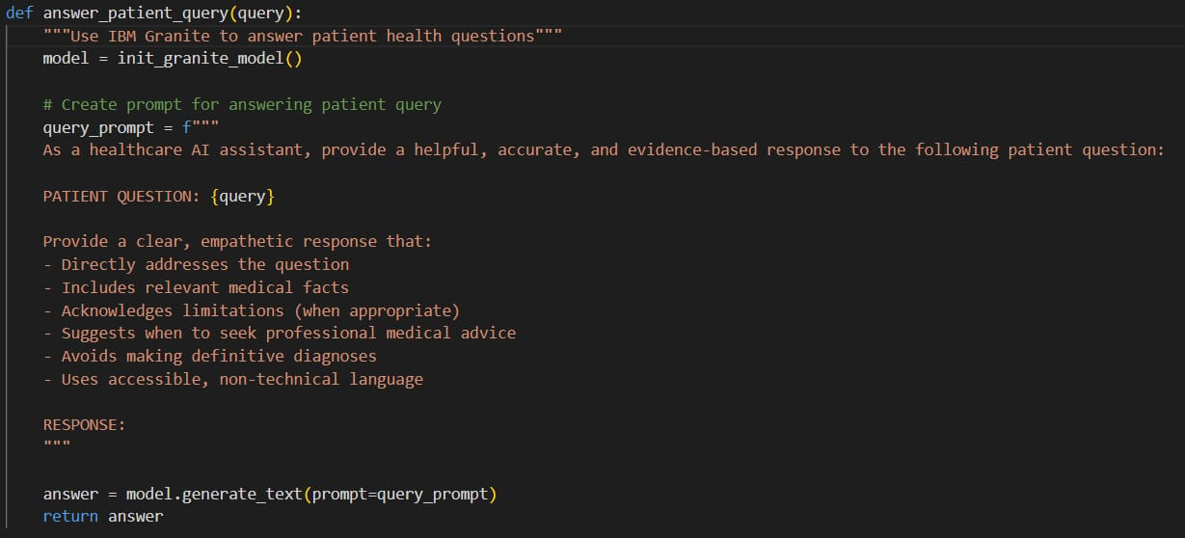

**Patient Query Prompting**

# Scope of the Project

## Project Limitations and Focus Areas

This project is focused on building a prototype AI assistant and does not include deployment in live hospital environments or integration with real patient data to ensure privacy. The focus is on chatbot query handling, EHR summarization using sample data, and symptom checking as a proof-of-concept using IBM Granite.

## Expected Outcomes of Health AI

The expected outcomes include a functional AI chatbot that can answer basic health-related queries, generate summaries of sample electronic health records, and perform symptom checks accurately while demonstrating the practical application of IBM Granite in healthcare automation.

**Tools and Skills Used in Health AI Internship**

## Streamlit Framework Knowledge

Streamlit is an open-source Python framework used to build and deploy interactive data applications quickly. During the internship, Streamlit was explored for rapid prototyping of healthcare dashboards and interactive data visualization interfaces, aiding in creating user-friendly front ends for AI models.

## IBM Watson Machine Learning

IBM Watson Machine Learning provides a cloud-based platform to deploy, monitor, and manage machine learning models at scale. This internship included learning how to deploy AI models using Watson ML, integrate them with the Health AI assistant, and ensure secure, scalable, and efficient operation in a cloud environment.

## Python Programming Proficiency

Python was the primary programming language used in developing Health AI modules, including chatbot workflows, data preprocessing pipelines, and backend API integration. It enabled efficient manipulation of data, rapid prototyping, and seamless integration with AI models.

## Data Visualization Libraries

Plotly, a powerful data visualization library, was used to create interactive charts and graphs to visualize healthcare data, chatbot analytics, and performance metrics. This helped in monitoring AI model outputs and analyzing healthcare data for insights.

## Version Control with Git

Git was used for version control to track changes in code, collaborate efficiently, and maintain backup checkpoints during development. It ensured structured workflow, rollback capability, and collaborative code management during the internship.

# Methodology / Implementation

## System Architecture Overview

The system architecture consists of a user interface where patients interact, backend services powered by IBM Granite Foundation Models, and a secure database to store interactions for analysis. It includes modules for chatbot handling, EHR summarization, and symptom checking, all connected through API-based microservices and deployed on IBM Cloud for scalability.

## Chatbot Development Steps

The chatbot was developed by integrating IBM Granite NLP capabilities to handle patient queries, using intent classification and entity extraction to understand user inputs and provide context-aware responses related to healthcare.

## EHR Summarization Pipeline

An NLP pipeline was designed using IBM Granite to extract, process, and summarize electronic health records into concise summaries, assisting healthcare professionals in quickly reviewing patient histories and important medical details.

## Symptom Checker Integration

A symptom checker module was implemented to collect patient symptoms via conversation, compare these against known medical datasets, and provide a preliminary analysis, guiding patients on possible conditions and advising on further consultation.

## Deployment Process on IBM Cloud

The developed Health AI assistant was containerized and deployed on IBM Cloud using Kubernetes services, ensuring high availability, scalability, and secure access for testing and future integration with healthcare systems.

# IMG_256

# Results and Observations

## Functional Demonstrations

The Health AI assistant was demonstrated with simulated patient queries to test chatbot response quality, EHR summarization using sample health records, and symptom checking workflows. Each module was verified for its functional correctness using test cases reflecting real-world healthcare scenarios.

## Performance and Accuracy

Performance was evaluated based on response time, accuracy of information provided by the chatbot, and summarization clarity. The assistant was able to generate concise summaries and respond to queries with a high level of accuracy, showcasing the effective application of IBM Granite for healthcare automation.

# Challenges Faced

## Technical Challenges

The project faced challenges in integrating IBM Granite models efficiently with the chatbot and summarization pipelines, ensuring accurate intent detection, and maintaining low latency during query responses.

## Data Privacy Concerns

Ensuring patient data privacy was a critical challenge, requiring the use of sample data only, anonymization practices, and designing the system architecture to align with healthcare data privacy guidelines such as HIPAA, while planning for secure handling in future real-world deployments.

# Learning Outcomes

## Technical Skills Gained

During the internship, skills such as Python programming for API integration, natural language processing using IBM Granite models, containerization with Docker, and cloud deployment on IBM Cloud were developed.

## Domain Knowledge Gained

The internship provided knowledge of healthcare workflows, patient data management, healthcare data privacy practices, and the practical application of AI in healthcare systems for real-world use cases.

# 

# Future Scope

## Speech-to-Text Integration

Future development can include adding speech-to-text capabilities, allowing patients to speak their queries, which would be converted into text for processing by the AI assistant, making the system accessible to users with different literacy levels.

## Multilingual Capabilities

Expanding the assistant to support multiple languages will make Health AI accessible to a broader patient base, enabling the system to serve in multilingual hospital environments and rural healthcare centers.

## Real Hospital System Integration Securely

The system can be integrated with real hospital management systems while ensuring end-to-end encryption, role-based access, and HIPAA-compliant data handling to enable seamless, secure, and practical deployment in live healthcare environments.

**Conclusion**

The Health AI internship project developed an intelligent assistant using IBM Granite to handle patient queries, summarize electronic health records, and perform symptom checks—all in one system. It demonstrated how generative AI can reduce repetitive tasks for healthcare professionals, improve patient support, and ensure data privacy. The project also provided hands-on experience in AI integration, cloud deployment, and real-world healthcare applications, highlighting the future potential of AI-driven, patient-centered care.

# References

* Streamlit Documentation
* IBM Watson ML Documentation
* [Python Documentation](https://docs.python.org/3/)
* Plotly Documentation
* [Git Documentation](https://git-scm.com/doc)